

R & PowerBI Assignment

Baraa Malki

# Contents

Step 1 – Initial Exploratory Analysis 2

Step 2 -Clean Data 3,4

Step 3 - Exploratory Data Analysis 5

Step 4 – Export Data 5,6

Step 5 – Create PowerBI Dashboard 5,6

Step 1 – load data

Step 2 - Clean data

Check for missing values

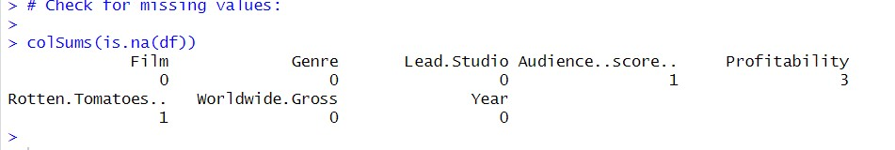

Drop missing values

Check to make sure missing values were removed

step 3 – exporatory data analysis

Summary statistics

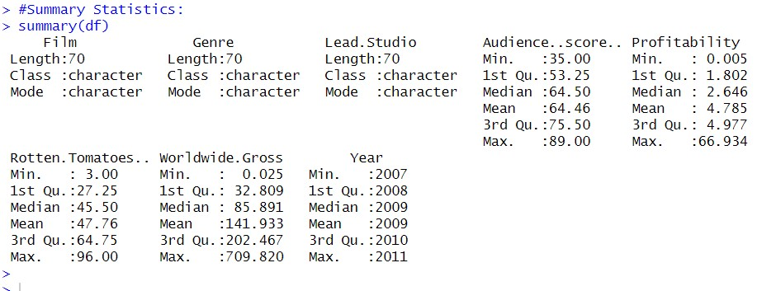

Scatter plot

Bar graph

Step 4 – export data

Step 5 – Create Powerbi dashboard

